Rockcastle County Free Bulk Trash Drop-Off Day
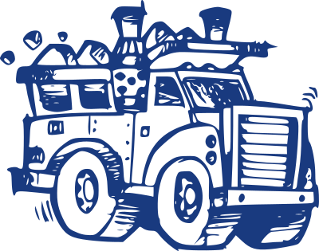
Will be held Saturday May 10, 2025
At the Brodhead Fairgrounds
From 8:00 a.m. to 3:00 p.m.

Items NOT Accepted:
Tires, limbs, leaves, liquids, paint, lumber, gas or propane containers, and hazardous materials.

Items Accepted
Household trash, bulk goods such as, couches, lawn furniture, televisions, electronics, bicycles, playground equipment, toys, mattress, boxspring, exercise equipment, etc…

