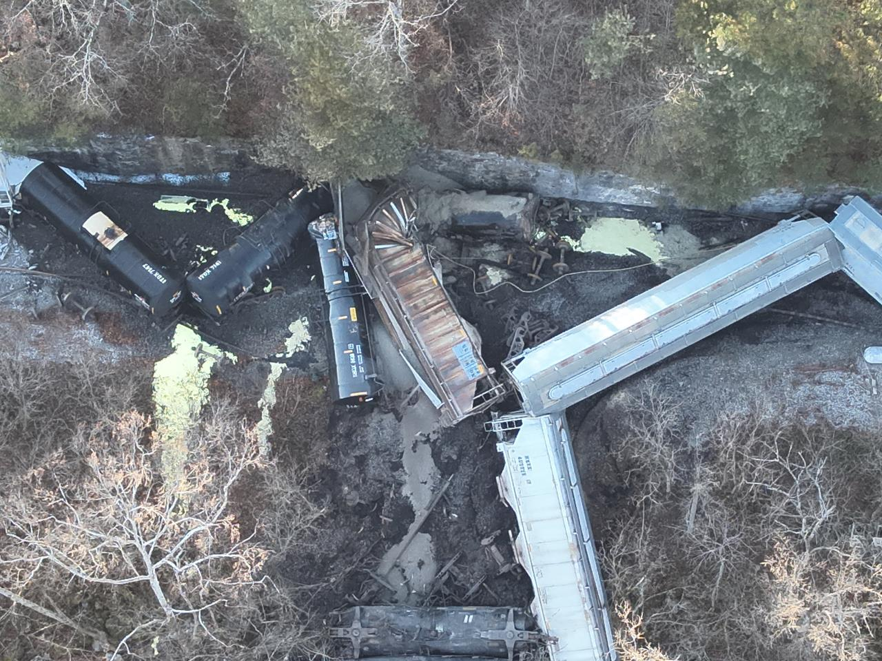
Site Contact:
Matthew Huyser
FOSC
(huyser.matthew@epa.gov)
Site Location:
Rail Milepost 00C138.84
Livingston, KY 40445
response.epa.gov/Livingston
NRC#: 1384928
The most up-to-date information can be found at the following online resources:
- RockcastleFiscalCourt.com
- facebook.com/RockcastleFiscalCourt
- CSX.com/response

Air Monitoring Summary Reports are available in the documents section of this webpage and are linked below. EPA continues to oversee and review air monitoring activities conducted by CSX
EPA and KYDEP | CSX
- November 23-24  - November 25 | - November 23 1am-5am  - November 23 5am-5pm

Background and EPA Response
On November 22 at approximately 2:30pm CSX reported a train derailment near Livingston, Rockcastle County, Kentucky. At the time of the report, thirteen rail cars were believed to have been derailed including tank cars of molten sulfur, at least one of which breached. Three tank cars containing magnesium hydroxide and one empty tank car that previously held methanol also derailed. The remaining derailed cars are reported to not contain hazardous substances. The terrain was found to be very challenging, slowing response and information-gathering.
The derailment is adjacent to the Roundstone Creek, which is a tributary of the Rockcastle River and the Cumberland River. The segment of Roundstone Creek near the derailment is currently a dry bed but may change with rain. The City of Livingston is just outside of the one-mile buffer of the derailment. No drinking water intakes were identified within twenty miles of the derailment site.
Local Emergency Management, Fire, and Police responded followed by CSX HAZMAT resources, Kentucky Department of Environmental Protection (KYDEP) Emergency Response, and Kentucky Emergency Management. A Region 4 Federal On-Scene Coordinator (FOSC) mobilized to join Unified Command.
Part of the spilled sulfur caught on fire resulting in a release of sulfur dioxide (SO2). Local officials issued a voluntary evacuation for residents downwind of the of the derailment site due to reports of sulfur like odors, burning eyes and throats. The evacuation area was increased when air monitoring detected SO2 in public areas excess of the EPA’s Acute Exposure Guideline Levels (AEGL). Unified Command engaged the Centers for Disease Control (CDC) Agency for Toxic Substances and Disease Registry (ATSDR) Emergency Response Program to provide public health information guidance.
Firefighting activities led by CSX on the morning of November 23 were successful and no SO2 detections were reported in Livingston after 0700 hours. No SO2 detections were reported at the derailment after the fire was extinguished. Local officials lifted the evacuation on the afternoon of November 23 and made the announcement at a press briefing that afternoon.
EPA remains integrated in Unified Command, conducting oversight of operations and reviewing operational plans for the response.

Further Information
- ATSDR ToxFAQs on Sulfur Dioxide
- Information about Acute Exposure Guideline Levels for airborne chemicals

